A+ Computer Science GOLF GAME PART I

Lab Goal : This lab was designed to teach you more object oriented programming and how to write a larger game.

Lab Description : Write an abstract Card class. Show that Card works as intended by completing the GolfCard class.

Rules for the GolfCard – Aces are 0, Jacks are 1, Queen and King are 10, and all other cards are face value.

This project will build a small scale version of a golf game. The objective of the golf game is to get the lowest score possible with a hand of 4 cards. You can have multiple players. One person must shuffle and deal the cards.

public abstract class Card
{
public static final String FACES[] = {"ACE","ONE","TWO","THREE","FOUR",
"FIVE","SIX","SEVEN","EIGHT","NINE","TEN","JACK","QUEEN","KING"};

private String suit;
private int face;
Files Needed ::
Card.java
GolfCard.java
CardTestOne.java

//constructors

//set methods
Sample Output ( CardTestOne.java )
ACE of HEARTS | value = 0
ONE of DIAMONDS | value = 1
FOUR of CLUBS | value = 4
JACK of SPADES | value = 11
QUEEN of HEARTS | value = 12
NINE of SPADES | value = 9
false
true
false
false

//get methods

public abstract int getValue();

//equals method

public String toString()
{
return FACES[face] + " of " + getSuit() + " | value = " + getValue();
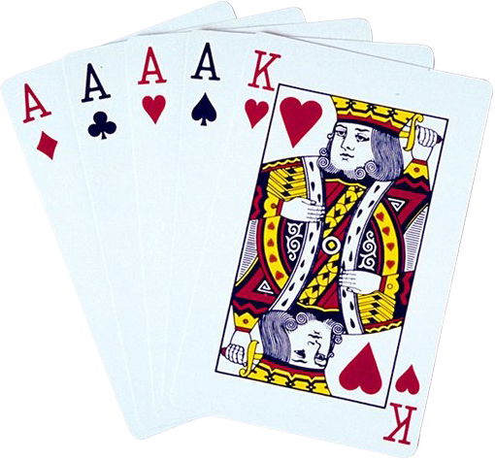
}
}

public class GolfCard extends Card
{

//constructors

public int getValue()
{
//ACES are 0, JACKS are 1, QUEEN is 10, King is 10, all others are face value
return 0;
}
}

